

**COMSATS University Islamabad (CUI)**

Lab Terminal Report

for

**StudyPoint: Online Tuition application**

***By***

**Hammad Tufail CIIT/SP20-BCS-028/ISB**

**Kulsoom Khurshid CIIT/SP20-BCS-044/ISB**

***Supervisor*Ma’am Gulmina Rextina**

*Bachelor of Science in Computer Science (2020-2024)*

**Part 1:**

**Storyboarding**

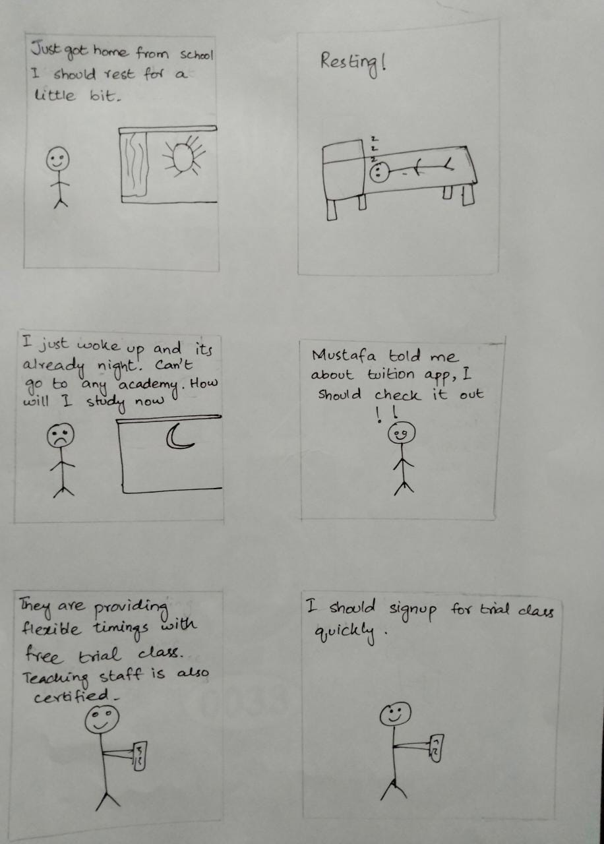

**Figure 1. Storyboard Depicting the Context for the Application.**

**Figure 2. Storyboard Depicting the student taking free trials and making decision based on the free trial.**

**Part 2:**

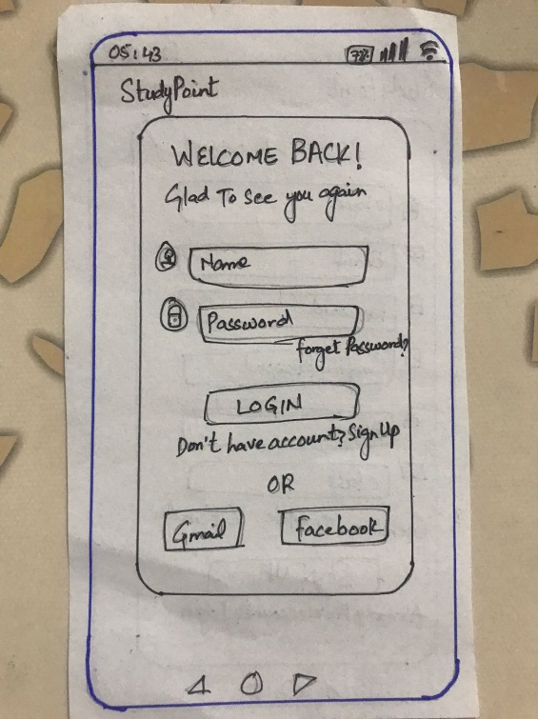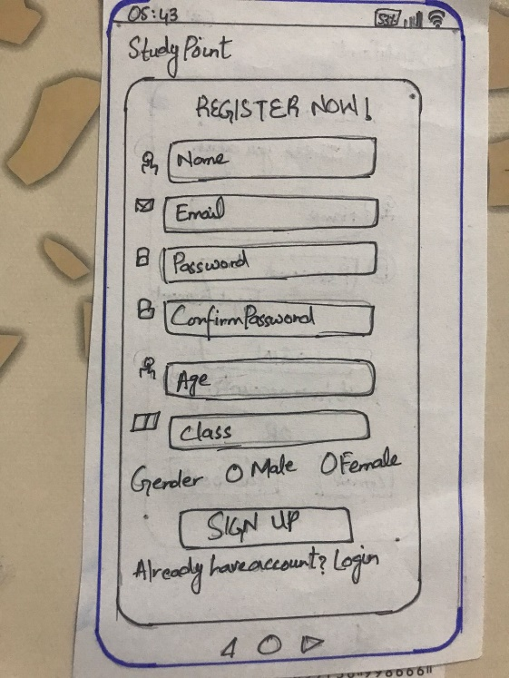**Card Based prototypes:**

**Figure 3. Card based prototype for signup. Figure 4. Card based prototype for login.**

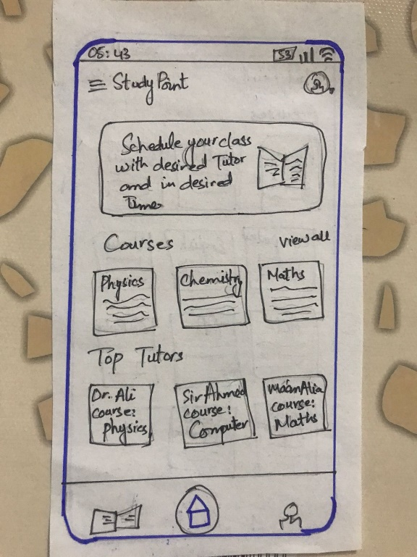

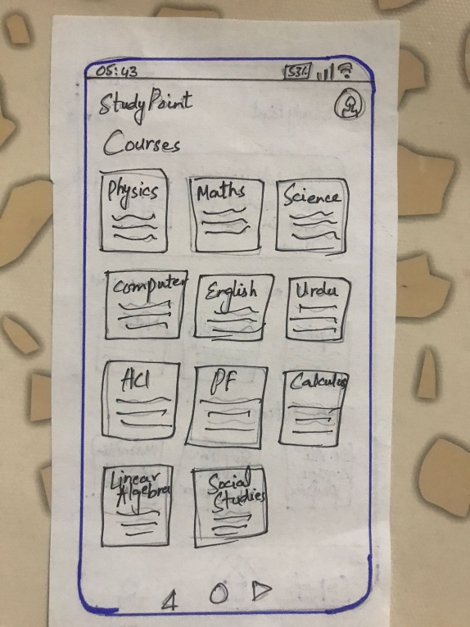

**Figure 5. Card based prototype for signup. Figure 6. Card based prototype for login.**

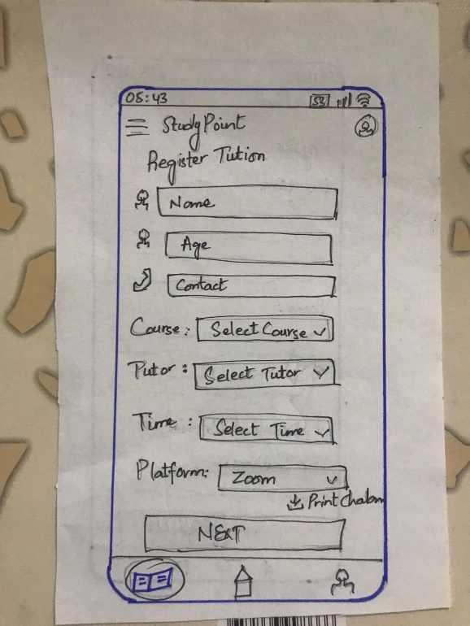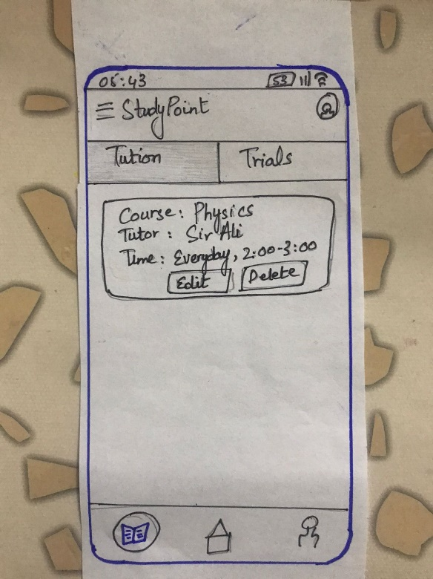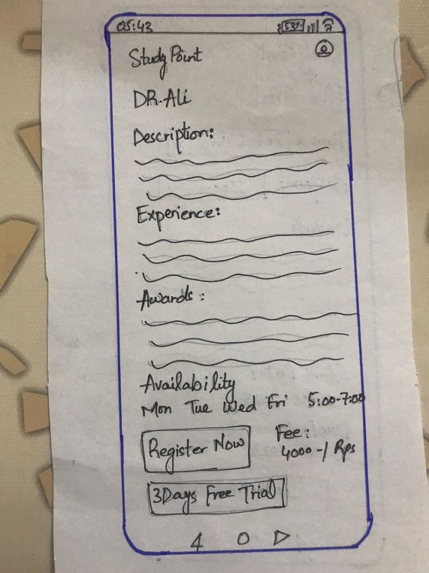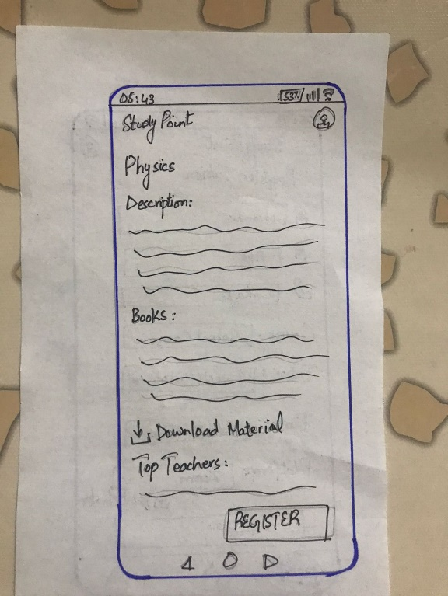

**Figure 7. Card based prototype for course details. Figure 8. Card based prototype for tutor details.**

**Figure 9. Card based prototype for registration. Figure 10. Card based prototype for view tuitions.**

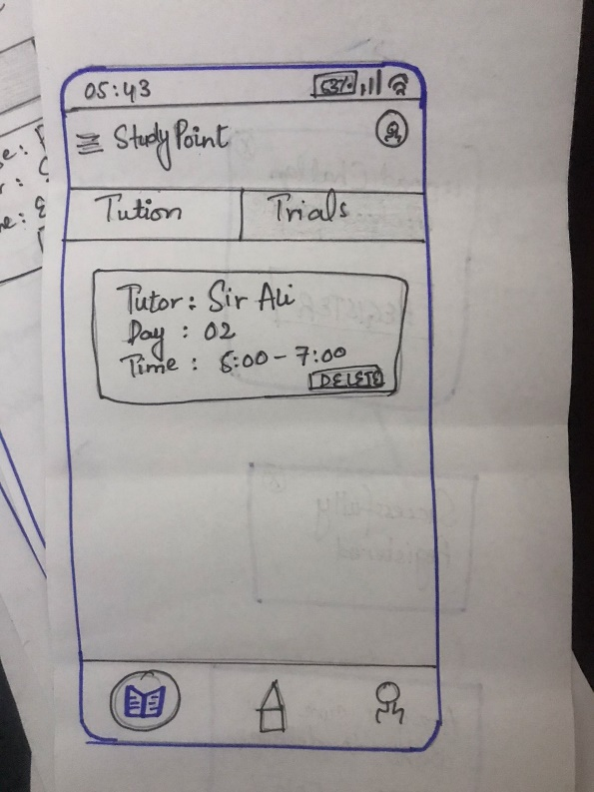

**Figure 11. Card based prototype for trial view. Figure 12. Card based prototype trial registration.**

**Part 3:**

**Formative evaluation:**

Links:

[https://youtu.be/pFeD8wZLy-E](https://youtu.be/pFeD8wZLy-E%20) (User 1)

<https://youtu.be/dPAOdP_llvc> (User 2)

Summary (Observer point of view):

We have assigned tasks to our users to validate if our application flow is understandable by users or not. We were keenly observing our users to see if they accomplish the desired task with ease or difficulty. The task given to our user 1 was to signup if not registered and then enroll to a desired course. User 2 was asked to delete the previously registered course and to opt for free trials before enrolling into another course.

The issues faced by our users while using the application are the following:

* In figure 5, on home screen the user 1 was confused if there are more top tutors or not as it doesn’t have any way to expand as the courses had view all option. So, the user was confused how to view other tutors.
* In figure 5 and 6, both the users suggested us to give more padding to make the content look less congested.
* User 1 was confused while enrolling for the course as she could not see any option on the home screen to register a tutor for a course. Eventually they found out later while they were looking at the specific tutor’s profile.

Solutions for these issues are as follows.

* We decided to add a plus button on the tab bar so the user would know that from there they can enroll into new tuition class.
* To avoid further confusion related to the popular tutor we added a slide to move through all the popular tutors available on our app.

The positive aspect of our application is that both the users were able to understand the application workflow very easily and quickly. The Entry Points for different screens were easy to identify, and the Participants navigated through the application without any hiccups.

**Part 4:**

**High fidelity prototypes:**

**Figure 13. Figma for start-up screen.**

**Figure 14. Figma for Login screen. Figure 15. Figma for Sign-up screen.**

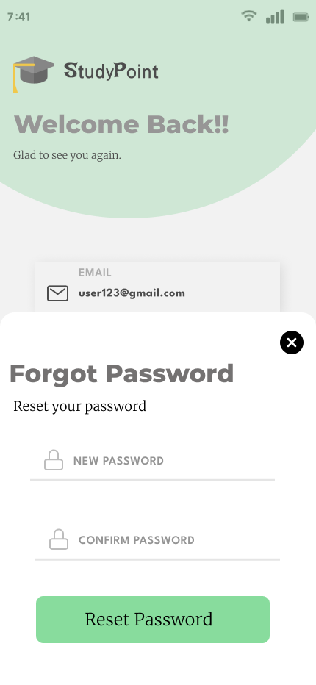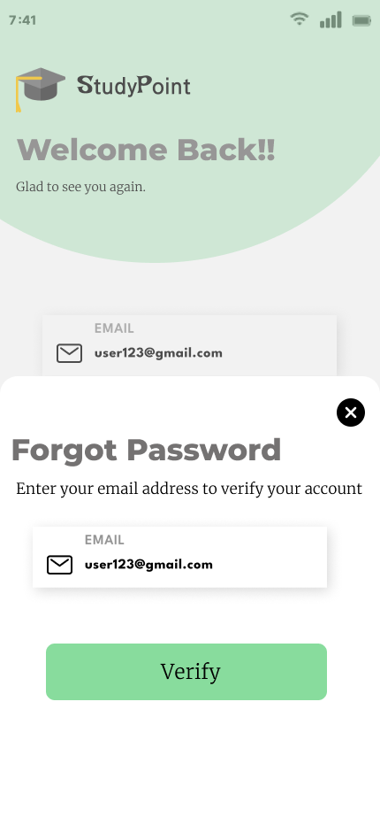

**Figure 16. Figma for forgetting password. Figure 17. Figma for Reset password.**

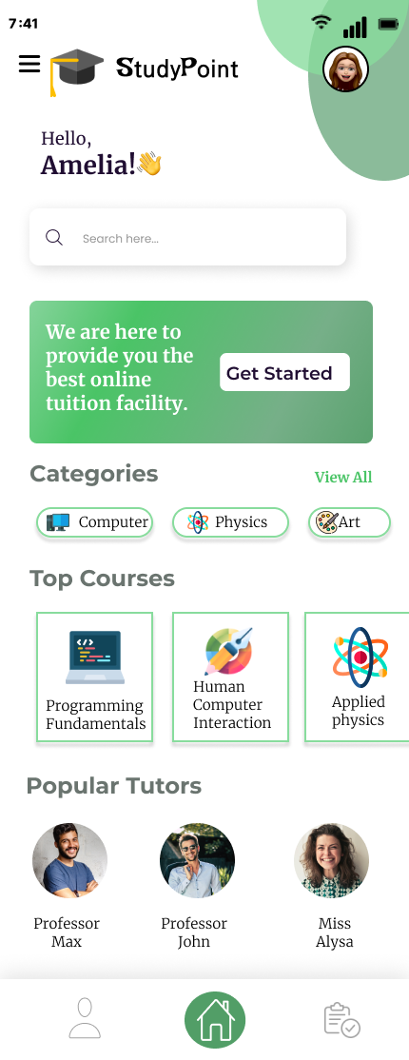

**Figure 18. Figma for Home screen.**

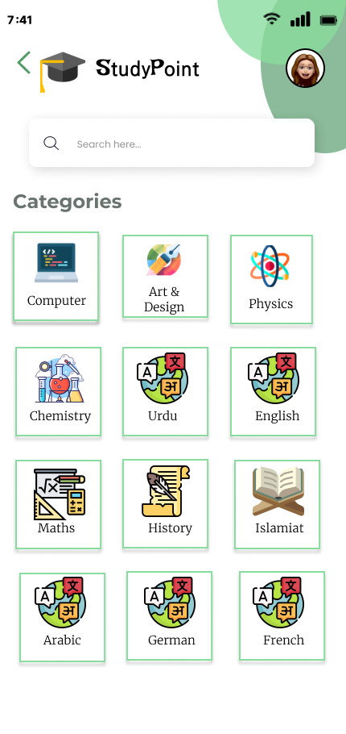

**Figure 19. Figma for all categories.**

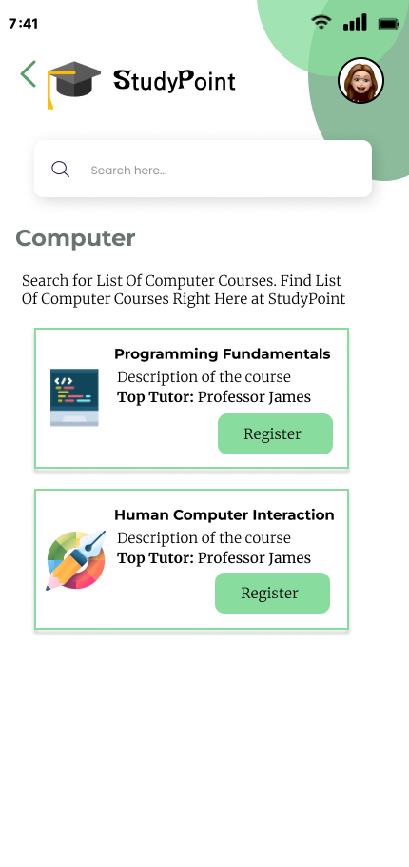

**Figure 20. Figma for all courses.**

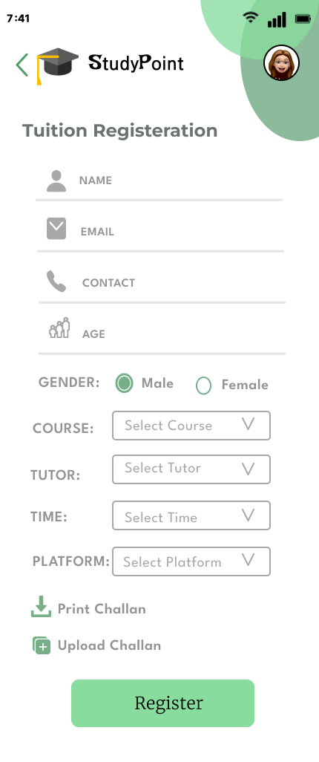

**Figure 21. Figma for tuition enrollment.**

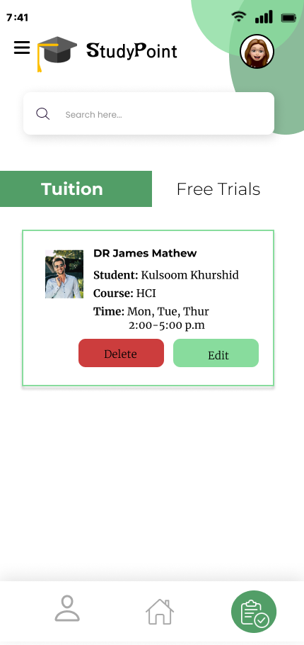

**Figure 22. Figma for tuition management.**

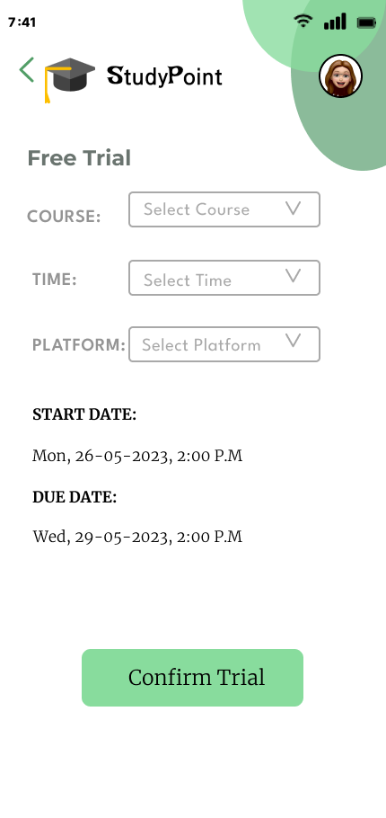

**Figure 23. Figma for trial registration.**

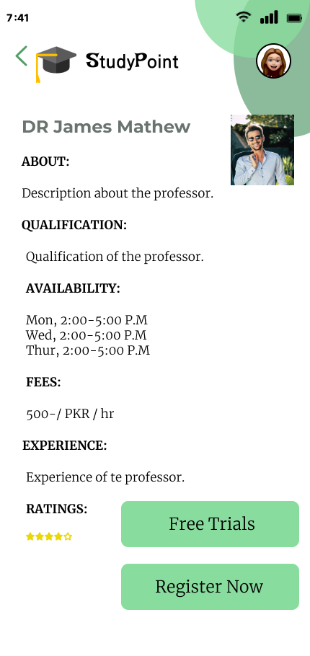

**Figure 24. Figma for tutor details.**

**Figure 25. Figma for trial management.**

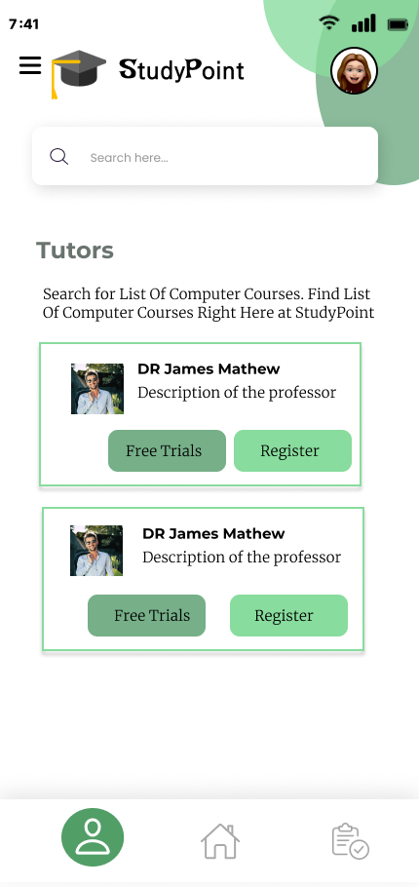

**Figure 26. Figma for all tutors.**

**Figure 27. Figma for course detail.**